THE RADAR TRACER IS FOR USE BY AGENTS OF THE UNITED STATES POLICE FORCE FOR COVERT OPERATIONS INTO THE NEW YORK CITY MAXIMUM SECURITY PENITENTIARY. EACH TRACER WILL BE PROGRAMMED WITH THE USERS USPF IDENTIFICATION NUMBER UPON ASSIGNMENT AND THE BACK STAMPED WITH THE USERS DESIGNATION AND NAME. THE TRACER IS DESIGNED TO BE INCONSPICUOUS TO OTHERS. THE TRACER IS MADE TO LOOK LIKE A BRACELET OR GAUNTLET WORN BY THE USER. THE USPF SYMBOL “EAGLE” CONCEALS THE TRACER ACTIVATION BUTTON. THE USPF SYMBOL IS ATTACHED AT THE BOTTOM BY A SPRING LOADED HINGE THAT CAN BE RELASED BY THE USER IN ORDER TO REVEAL THE TRACER ACTIVATION BUTTON. THE USER CAN RELEASE THE SAFETY CATCH BY TURNING THE TRIGGER KNOB, LOCATED AT THE TOP OF THE MECHANISM, A
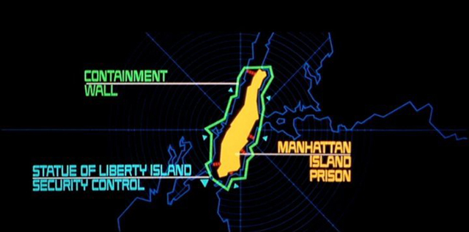
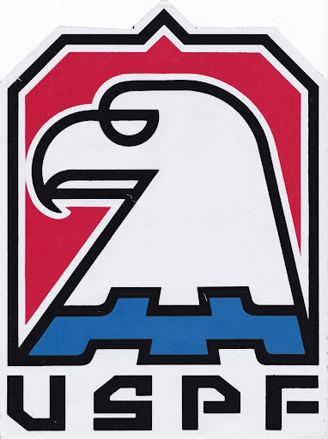
QUARTER TURN COUNTER CLOCKWISE UNTIL THE USPF SYMBOL RELEASES. THE TRACER ACTIVATION BUTTON IS NOW ABLE TO BE ACTIVATED. THE USER CAN ACTIVATE THE TRACER AND BE TRACKED ON RADAR BY USPF COMMAND FOR 15 MINUTES. ONCE THE TRACER IS ACTIVATED THE USER SHOULD LATCH THE USPF SYMBOL AGAIN BY CLOSING THE LATCH AND TURING THE TRIGGER KNOB A QUARTER CLOCKWISE UNTIL SECURE.

